Chiteri, Martin Akolo **Student ID:** 1231525 *CIV E 606 Assignment 4* ***8th March, 2016***

**Question ONE**

i) Determine the utilization and queue length associated with shovels and crusher

ii) Which of the truck sizes is more productive at the end of the stipulated duration?

iii) What is the average cycle length for small and large trucks?

**Question TWO**

1. *How much time and money does it take to obtain a successful contract?*

**Duration** spent is 52,070.25 hours in total from 148 bids successful observed. The average time observed for all averages is **351.83 hours.** See screenshot attached below of the associated statistic collect element.

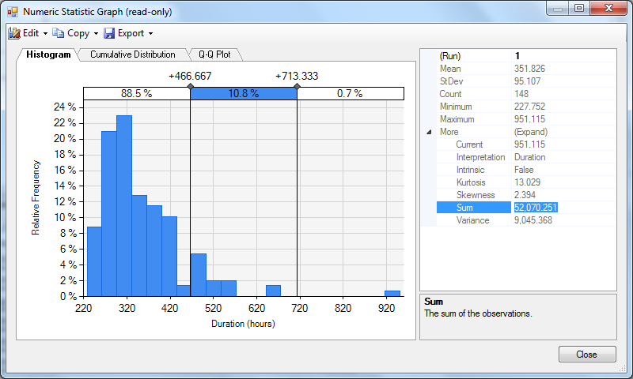

The amount of **money** spent is $ 1,777,243.01 in total from 148 successful bids. The average amount observed for all averages is $ **12,008.40.** See screenshot attached below of the associated statistic collect element.

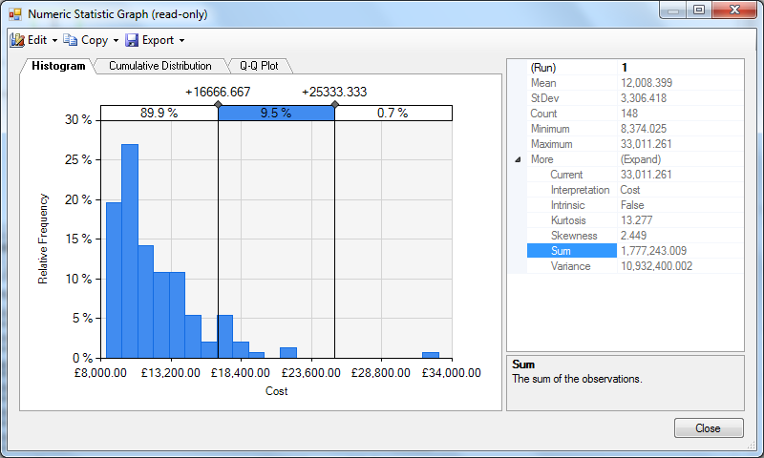

1. How much time and money is spent in bidding for contracts that are lost?

**Duration** spent is 139,819.84 hours in total from 852 lost bids observed. The average time observed for all averages is **164.19 hours.** See screenshot attached below of the associated statistic collect element.

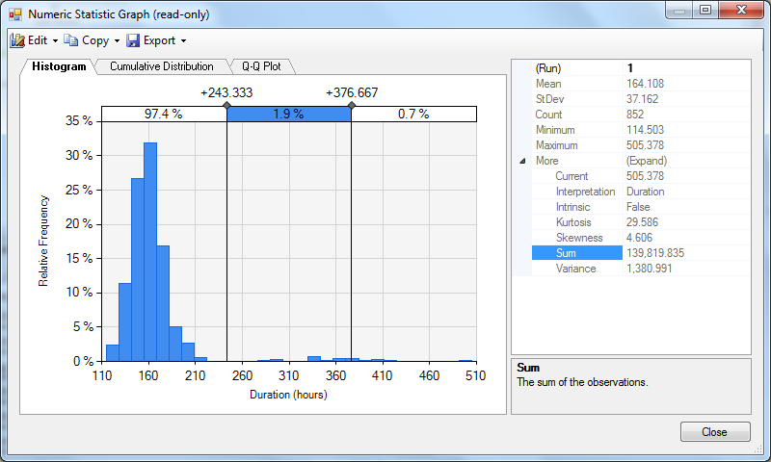

The amount of **money** spent is $3,552,529.98 in total from 852 lost bids. The average amount observed for all averages is $ **4,169.64.** See screenshot attached below of the associated statistic collect element.

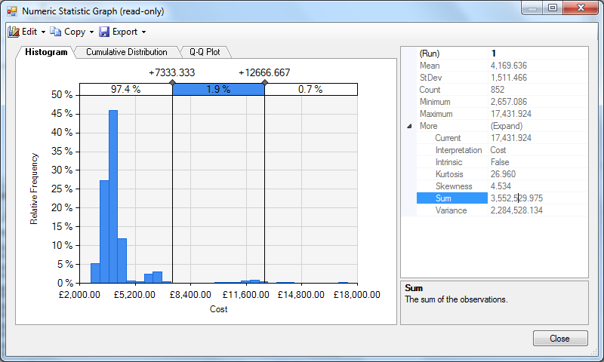

iii) *What is the probability of winning and losing a contract?*

*The probability of winning a contract*

= (0.95 x (0.9 x 0.8) x 0.44) = 0.1871 or 18.71%, That is without revisions & modifications after a single pass

= (0.95 x (0.9 x 0.8) x 0.44 x 0.88) = 0.1646 or 16.46%, With a revision & modifications after a single pass

*The probability of losing a contract*

= 1 – (0.95) = 1 – 0.59 = **0.4**1 or **41%**, if the first internal study report is not recommended

= 1 – (0.95 x (1 – 0.95)) = **0.7581** or **75.81%**, If the first internal study report is recommended but not approved

1. *How much time and money are spent in the first phase of the bidding process (after finishing the first internal study)?*

**Duration** spent is 156,358.50 hours in total from 1,000 bids for contracts. The average time observed for all averages is **156.36 hours.** See screenshot attached below of the associated statistic collect element.

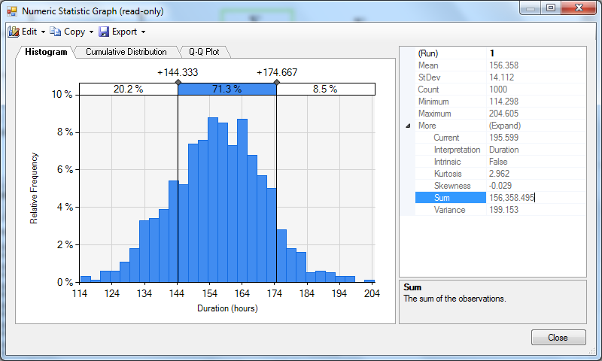

The amount of **money** spent is $ 3,793,780.38 in total from 1,000 bids for contracts. The average amount observed for all averages is $ **3,793.78.** See screenshot attached below of the associated statistic collect element.

